**Praktikum 3 Sistem Basis Data 2023**

**NRP / Nama : 5025221161/Mohammad Hanif Furqan Aufa Putra  
Kelas : J**

**RDBMS : MySQL**

**Link SQL :** [**https://drive.google.com/drive/folders/1o3mrNrde-VpRxfJPP5G0dav-v6Mvot3B?usp=drive_link**](https://drive.google.com/drive/folders/1o3mrNrde-VpRxfJPP5G0dav-v6Mvot3B?usp=drive_link)

**Kode Asdos : J02**

**Sesi : Praktikum**

**Nomor 1**

Sintaks:

SELECT M_Nama, M_Harga, M_Deskripsi

FROM Menu

WHERE M_Harga <= 15000

AND (LOWER(M_Nama) NOT LIKE '%ayam%' AND LOWER(M_Deskripsi) NOT LIKE '%ayam%');

Hasil:

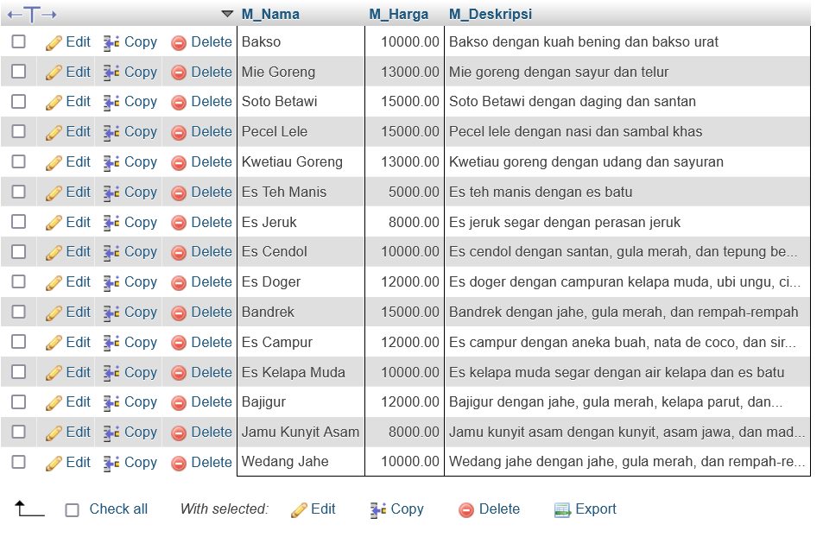

**Nomor 2**

Sintaks:

SELECT

    C_Nama AS Customer_Name,

    GROUP_CONCAT(M_Nama) AS Purchased_Menus,

    SUM(M_Harga) AS Total_Spent

FROM

    Customer

JOIN

    Transaksi ON C_ID = Customer_C_ID

JOIN

    Menu_Transaksi ON T_ID = Transaksi_T_ID

JOIN

    Menu ON M_ID = Menu_M_ID

WHERE

    C_Nama = 'Lisa Davis'

GROUP BY

    C_Nama;

Hasil:

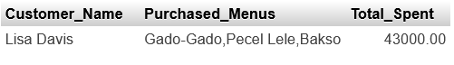

**Nomor 3**

Sintaks:

SELECT

    Transaksi_T_ID AS Transaction_ID,

    COUNT(Menu_M_ID) AS Number_of_Menus,

    SUM(M_Harga) AS Total_Price

FROM

    Menu_Transaksi

JOIN

    Menu ON M_ID = Menu_M_ID

GROUP BY

    Transaksi_T_ID

ORDER BY

    Number_of_Menus DESC,

    Total_Price DESC;

Hasil:

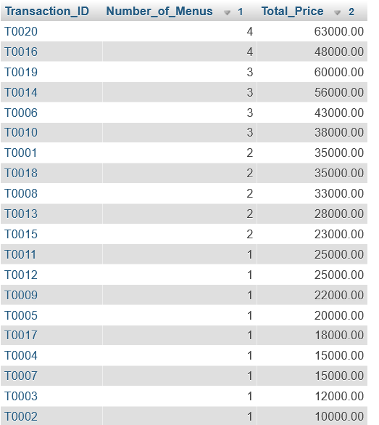

**Nomor 4**

Sintaks:

SELECT D_Nama, D_Rating

FROM Driver

WHERE D_Rating > (SELECT AVG(D_Rating) FROM Driver);

Hasil:

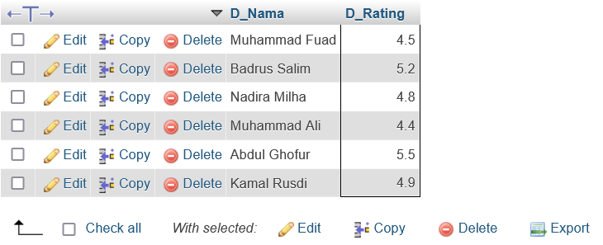

**Nomor 5**

Sintaks:

SELECT

    T_WaktuPesanan AS Order_Date,

    COUNT(T_ID) AS Number_of_Transactions

FROM

    Transaksi

GROUP BY

    T_WaktuPesanan

ORDER BY

    T_WaktuPesanan DESC;

Hasil:

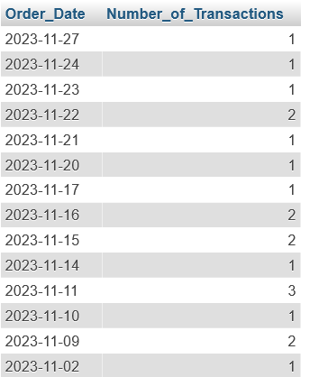

**Nomor 6**

Sintaks:

SELECT

    P_Jabatan AS Employee_Type,

    COUNT(P_ID) AS Number_of_Employees,

    AVG(P_Gaji) AS Average_Salary

FROM

    Pegawai

GROUP BY

    P_Jabatan;

Hasil:

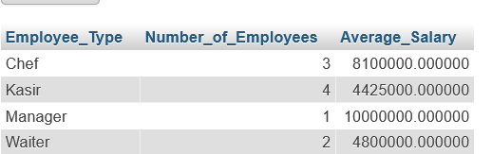

**Nomor 7**

Sintaks:

SELECT

    P_Nama AS Employee_Name,

    COUNT(DISTINCT Customer_C_ID) AS Number_of_Customers

FROM

    (SELECT

        Customer_C_ID,

        Pegawai_P_ID,

        ROW_NUMBER() OVER(PARTITION BY Customer_C_ID ORDER BY COUNT(T_ID) DESC) as rn

     FROM

        Transaksi

     GROUP BY

        Customer_C_ID,

        Pegawai_P_ID) as T

JOIN

    Pegawai ON P_ID = Pegawai_P_ID

WHERE

    rn = 1

GROUP BY

    P_Nama

ORDER BY

    Number_of_Customers DESC;

Hasil:

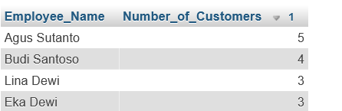

**Nomor 8**

Sintaks:

SELECT

    SUM(CASE

        WHEN T_MetodePembayaran IN ('Debit Card', 'Credit Card')

        THEN M_Harga * 0.95

        ELSE M_Harga END) * 0.4

        AS Profit

FROM

    Transaksi T

    JOIN Menu_Transaksi MT ON T.T_ID = MT.Transaksi_T_ID

    JOIN Menu M ON MT.Menu_M_ID = M.M_ID

WHERE

    MONTH(T.T_WaktuPesanan) = 11;

Hasil:

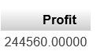

**Nomor 9**

Sintaks:

SELECT

    SUM(CASE WHEN DAYOFWEEK(T_WaktuPesanan) IN (1, 7) THEN 1 ELSE 0 END) -

    SUM(CASE WHEN DAYOFWEEK(T_WaktuPesanan) NOT IN (1, 7) THEN 1 ELSE 0 END) AS Difference_Transaction,

    SUM(CASE WHEN DAYOFWEEK(T_WaktuPesanan) IN (1, 7) THEN harga ELSE 0 END) -

    SUM(CASE WHEN DAYOFWEEK(T_WaktuPesanan) NOT IN (1, 7) THEN harga ELSE 0 END) AS Difference_Income

FROM (

    SELECT DISTINCT T_WaktuPesanan, SUM(menu.M_Harga) as harga

    FROM transaksi

    JOIN menu_transaksi ON transaksi.T_ID = menu_transaksi.transaksi_t_id

    JOIN menu ON menu_transaksi.menu_m_id = menu.M_ID

    GROUP BY transaksi.T_ID

) as selisih;

Hasil:



**Nomor 10**

Sintaks:

SELECT

    D_Nama AS Driver_Name,

    COUNT(Menu_M_ID) AS Number_of_Menus

FROM

    Transaksi T

JOIN

    Menu_Transaksi MT ON T.T_ID = MT.Transaksi_T_ID

JOIN

    Driver D ON T.Driver_D_ID = D.D_ID

GROUP BY

    D_Nama

ORDER BY

    Number_of_Menus DESC;

Hasil:

